SMART WATER TRACKER

Project Report Submitted to

Department of Physics, School of Science and Humanities,
Shiv Nadar University Chennai
In partial fulfillment of the requirements for the award of the
Degree of Bachelor of Technology in Computer Science and Engineering with Specialisation in Internet of Things

BY

M Udhaya (24011102053)
M Rathish Roshaan (24011102051)
J Sidtharth (24011102037)
Aditya A S (24011102004)

DEPARTMENT OF COMPUTER SCIENCE AND ENGINEERING
SCHOOL OF ENGINEERING
SHIV NADAR UNIVERSITY CHENNAI

APRIL 2025

SELF ATTESTATION

This is certifying that, we have personally worked on the project entitled “SMART WATER TRACKER”. A case study and data mentioned in this report was obtained during genuine work done and collected by us.
Any other data and information in this report, which has been collected from outside agency, has been duly acknowledged.

STUDENTS

Aditya A S (24011102037)

J Sidtharth (24011102004)

M Rathish Roshaan (24011102051)

M Udhaya (24011102053)

Date: 29/04/2025
Place: Shiv Nadar University Chennai

TABLE OF CONTENT

S. No | Title | Page No.
1 | Introduction | 1
2 | Overview | 1
3 | Objective | 1
4 | Theory and Derivations | 2
5 | Materials Specifications | 2
6 | Setup | 3-4
7 | Output | 5
8 | Result | 6
9 | Conclusion | 7
10 | References | 7

FIGURE OF CONTENT

Fig.1. Circuit Schematic of Smart Water Tracker

Fig.2. Prototype Model

Fig.3. Circuitry when embedded with an OLED Display

Symbol Explanation

Symbol | Explanation
VCC | Voltage Supply (+5V)
GND | Ground
SDA | Serial Data Line for I2C (RTC Communication)
SCL | Serial Clock Line for I2C (RTC Communication)
Trig | Trigger pin for Ultrasonic Sensor
Echo | Echo pin for Ultrasonic Sensor
cm | Centimeters (distance/water height measurement)
ms | Milliseconds (time measurement in code)
RTC | Real Time Clock

1.Introduction:

Water is an essential element for life, and staying hydrated is crucial for maintaining good health. However, in our busy lifestyles, we often forget to drink sufficient water at regular intervals. To solve this problem, a “Smart Water Tracker” has been developed. This device continuously monitors the water level in a bottle, reminds the user to drink water at timely intervals, and motivates the user through interactive messages, ensuring optimal hydration.

2.Overview:

This project presents a cost-effective and offline Smart Water Tracker system using Arduino UNO, Ultrasonic Sensor, RTC DS3231, and Buzzer. The tracker measures the water level in real-time, reminds users to drink water hourly, records drinking instances, monitors inactivity, and motivates users with encouraging messages — all without using Wi-Fi or external networks.

3.Objective:

- To develop a low-cost, offline Smart Water Tracker.
- To continuously monitor the water level in a bottle.
- To alert users if the water level is low.
- To provide hourly hydration reminders.
- To track the number of drinking events daily.
- To motivate users through interactive messages.
- To monitor hydration inactivity and alert after prolonged periods without drinking.

4. Theory and Derivations

- Ultrasonic Sensing Principle: Distance = (Time × Speed of Sound) / 2 Water Height = Maximum Water Height − Distance
- Real-Time Clock (RTC) Principle: RTC keeps track of the real-world time and date, enabling event triggering based on hourly or daily timings.
- Buzzer Notifications: Buzzer alerts generate sound reminders at specific hydration milestones and low water warnings.
- Programming Logic:

- Measure water level every loop.
- Display water level data every 20 seconds.
- Trigger buzzer for low water level (<5 cm).
- Hourly drink reminder via buzzer and serial message.
- Drink events are logged if water height drops by 3 cm or more.
- Inactivity alert after 2 hours without drinking.
- Hourly time chime at full hour.
- Drink count reset at midnight.

5. Materials (Specifications):

Component | Specification
Arduino UNO | ATmega328P, 5V Logic
HC-SR04 Ultrasonic Sensor | Range: 2cm – 400cm, Accuracy ±3mm
DS3231 RTC Module | Temperature-compensated crystal oscillator, battery backup
Passive Buzzer | Operating Voltage: 3V – 5V
Jumper Wires | All type connections
Power Source | USB Cable or Battery Pack

6. Setup:
Step 1: Component Setup
- Collect all required components: Arduino UNO, HC-SR04 Ultrasonic Sensor, DS3231 RTC Module, Passive Buzzer, jumper wires, and a USB cable.
- Ensure all components are working properly before starting the assembly.

Step 2: Circuit Assembly
- Connect the HC-SR04 Ultrasonic Sensor:
  - Trig pin → Arduino digital pin 9, Echo pin → Arduino digital pin 10, VCC → 5V, GND → GND
- Connect the DS3231 RTC Module:
  - SDA → Arduino A4, SCL → Arduino A5, VCC → 5V, GND → GND
- Connect the Passive Buzzer:
  - Positive terminal → Arduino digital pin 8
  - Negative terminal → GND
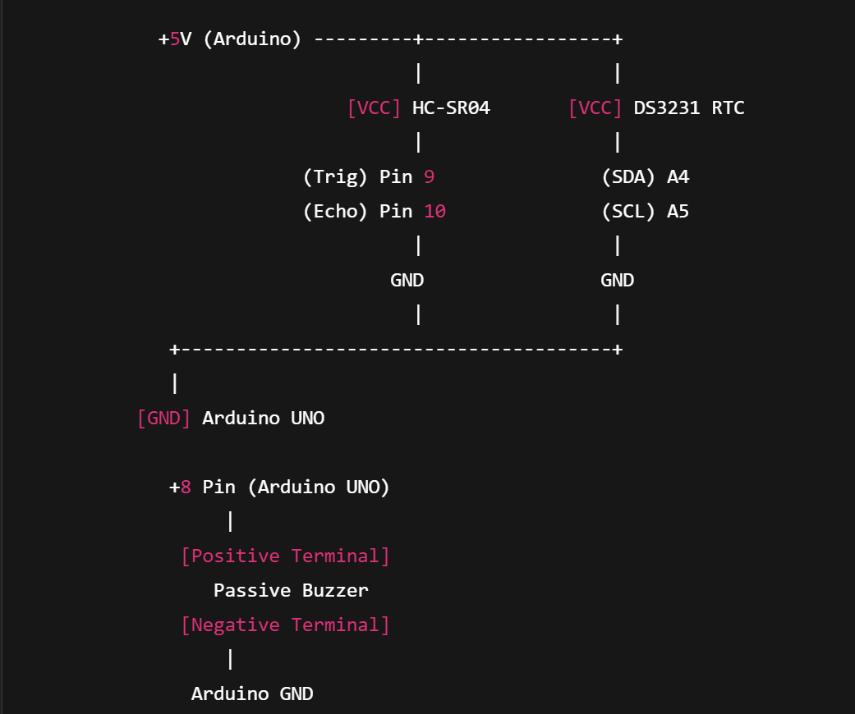

Fig. 1: Circuit Schematic

Step 3: Programming the Arduino
- Open Arduino IDE on your computer.
- Install required libraries if not already installed:
  - RTClib for the DS3231 RTC module.
- Upload the Smart Water Tracker V2 code to the Arduino UNO board.
- (Optional) Uncomment and run the rtc.adjust(DateTime(...)) line ONCE to set the correct date and time on the RTC module.

Step 4: Calibration and Testing
- Place the ultrasonic sensor above the water bottle at a fixed distance.
- Upload the code and open the Serial Monitor at 9600 baud rate.
- Observe the initial water level readings to ensure proper sensor functioning.
- If necessary, adjust the sensor position slightly for maximum accuracy.

Step 5: System Monitoring
- Monitor the Serial Monitor for outputs every 20 seconds.
- Verify that:
  - Hourly drink reminders are triggered correctly.
  - Low water level alerts work when the bottle is low.
  - Drink events are logged when water is consumed.
  - Inactivity alerts are raised after 2 hours without drinking.
  - Daily reset occurs at midnight.

Step 6: Final Validation
- Confirm that the buzzer, RTC, and ultrasonic sensor are functioning as expected without any false triggering.

7. Output:

- Current Time and Date
- Current Water Level (cm and %)
- Total Drinks Taken Today
- Motivational Message based on water level
- Hourly Reminders
- 2-Hour No-Drink Warnings
- Low Water Level Alerts
- Sound alerts via Buzzer

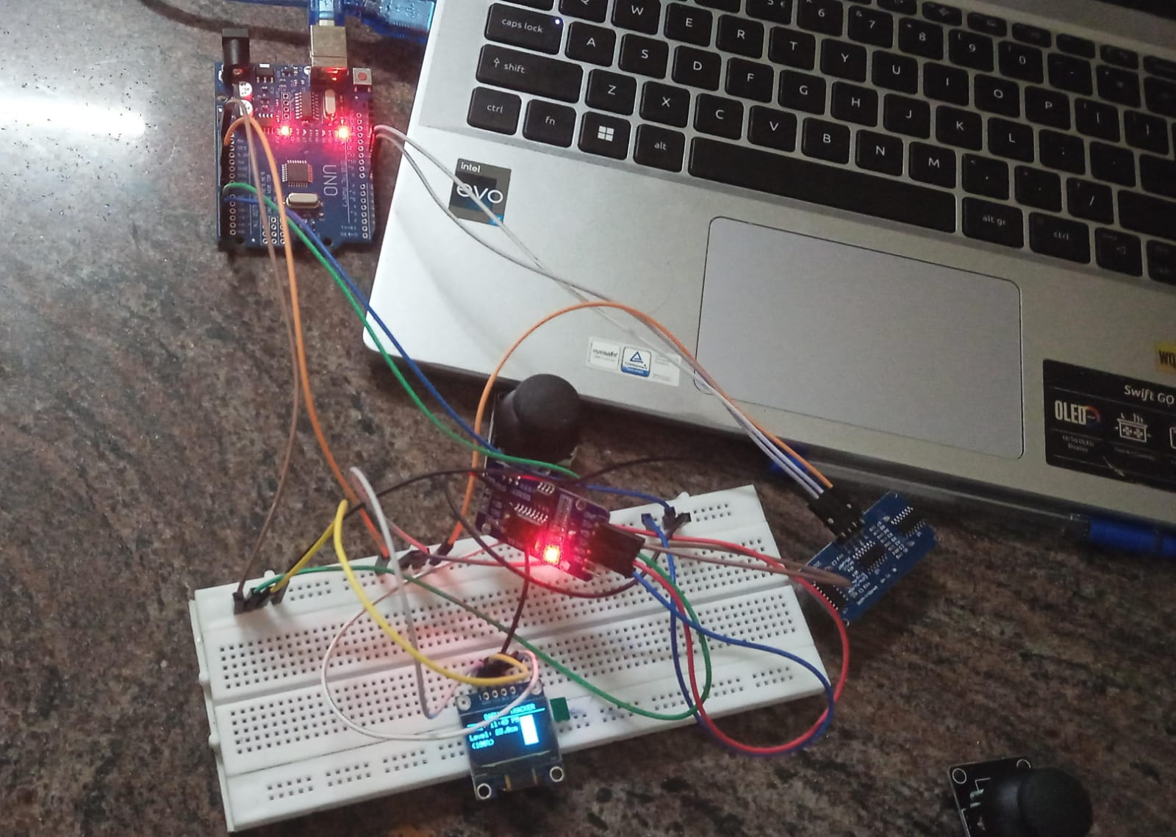
Fig. 2: Prototype Model

8. Result:

The Smart Water Tracker performed reliably, providing:
- Accurate water level monitoring (error ±1 cm)
- Regular hourly hydration reminders
- Drink event tracking through water level changes
- Effective inactivity warnings
- Smooth daily resets without manual intervention

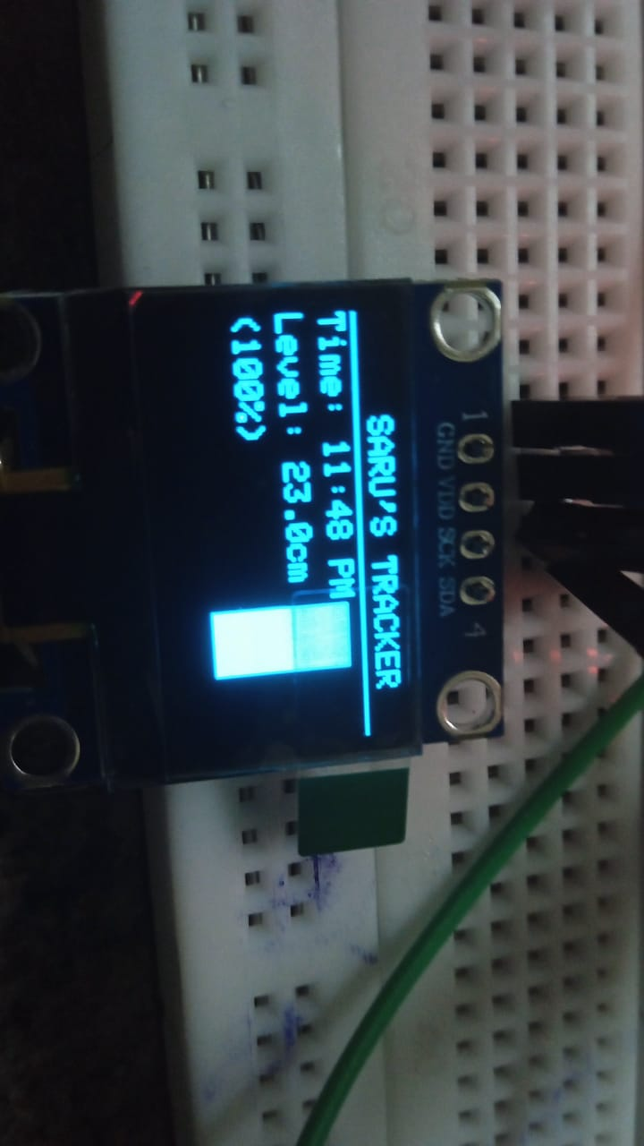
Fig 3: Model when embedded with an OLED Display

9. Conclusion

The Smart Water Tracker is an effective and economical hydration monitoring solution. Built with basic hardware and Arduino programming, it achieves real-time monitoring, timely hydration prompts, motivational support, and inactivity detection without relying on the internet. Future expansions could include OLED displays, SD card data logging, or IoT capabilities.

10. References

- Arduino Documentation - https://www.arduino.cc/en/Guide
- HC-SR04 Sensor Datasheet - https://cdn.sparkfun.com/datasheets/Sensors/Proximity/HCSR04.pdf
- DS3231 RTC Module Datasheet - https://datasheets.maximintegrated.com/en/ds/DS3231.pdf
- Practical Arduino Projects by Jonathan Oxer

